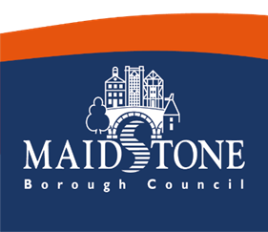
Parish Newsletter
December 2025

Local Government Reorganisation December Update
In one of the biggest changes to local government in 50 years, government ministers asked local councils to deliver proposals to create unitary councils.
On Friday 28 November the proposals for the preferred number of new councils needed for Kent and Medway, and the geographical areas they should cover, were submitted to the government.
Under the current system Kent County Council (KCC) delivers some services such as education, social services and roads, and district or borough councils deliver others like emptying your bins and providing housing services.
Under the proposed system, unitary councils would deliver all council services in one area. Medway Council operates in that way today.
During November, councillors across Kent and Medway met to decide their preference.
Details of the submission made by Maidstone Borough Council and the other Kent councils can be found here Devolution - Maidstone Borough Council along with more information and the timeline expected for Local Government Reorganisation.

Have your say on Reducing and Preventing Violence Against Women & Girls in Maidstone
Maidstone Borough Council (MBC) is developing a new strategy to reduce and prevent Violence Against Women and Girls (VAWG) across the borough. We are calling on all residents, community groups, VCS organisations, and Parish Councils to join us in this vital work.
Your participation, both through sharing your experiences and helping us promote these opportunities, is essential to ensure this strategy is rooted in the needs of our entire community.
- Share Your Views: Complete Our VAWG Surveys
- Your feedback is vital in helping MBC and its partners understand the issues and shape effective, community-led recommendations.
- We strongly encourage all staff, volunteers, and representatives from our VCS and Parish partners to complete and widely promote the relevant surveys.
- For All Residents: Share your experiences and priorities on VAWG in Maidstone. Start the General Survey Here
- For Young Residents: We need to hear from young residents (no matter their gender) about their thoughts and experiences. Start the Youth Survey Here
2. Get Involved: Maidstone Together - A Community Discussion
We are also launching Maidstone Together: A Community Discussion to bring together a group of residents to look deeper into the issue of VAWG. Participants will hear from experts, share experiences, and co-create practical, resident-led recommendations for the Council and its partners to take forward.
This is a powerful opportunity to influence long-term policy and create lasting change.
- Find out more about the discussion group and register your interest in participating: Help shape a safer Maidstone | Involve
A request to all our partners: Please help us reach every corner of Maidstone by sharing these links through your own communication channels - including your websites, social media, and newsletters. Ending VAWG requires all of us to act. Thank you for your support in promoting this important work.

Community Cookbook - We want your favourite recipes!

Food brings people together and should be a source of comfort and joy, while making us feel good in body and mind.
We want to bring together nourishing recipes from our community to create a community cookbook that we can then share with our communities and encourage cooking healthy, budget friendly meals.
To submit a recipe simply fill out this Microsoft Maidstone Community Cookbook Recipe Submission – Fill in form
OR send your recipe to healthyalliance@maidstone.gov.uk with the following information:
- Your Name
- Your Recipe including ingredients and method
- Why you love the recipe
If you would like some printed leaflets to share with your service users - send us an email and we can drop them off to you. All recipes included in the book will receive a gift.

Smokefree Spaces
We are running an initiative across Maidstone, asking people not to smoke or vape in entranceways to public buildings and at children's play areas. It has had a positive impact so far and we are able to now offer free signage to all VCSE organisations if you would ike signage around your building or outside areas. We are also able to install it free of charge.
See attached flyer.
Email christinebrowne@maidstone.gov.uk if you would like signage.

Energy saving support for vulnerable households
MBC are working with Involve Kent to delivery warmer homes for vulnerable residents with health conditions this winter. This support includes a home safety check and visit from a handyman to install energy saving retro-fit solutions, such as heat reflecting radiator foil, draft excluders, thermal curtains, thermal window film and many more. Residents who are struggling with a cold home and looking for support should contact our Customer Services Helpline on 01622 602000 for further welfare support and to discuss their eligibility. Cost of living support is available on our website here.
Cost of living advice | Maidstone Borough Council

Free Carbon Literacy Training for Parish Councils

We’re offering a free accredited Carbon Literacy course designed specifically for Parish Councils. This full-day training will give you the knowledge, confidence, and practical tools to take meaningful climate action in your role and community.
Carbon Literacy training is an accredited course which aims to create “An awareness of the carbon costs and impacts of everyday activities, and the ability and motivation to reduce emissions, on an individual, community and organisational basis” Around one-third of the UK’s carbon emissions are shaped by local authority decisions, policies, and partnerships—giving local councils a crucial role in driving the nation’s transition to net zero
Why attend?
✔ Understand the science and impacts of climate change on our communities
✔ Explore the unique role of local and parish councils in driving decarbonisation
✔ Learn from real-world examples of carbon reduction
✔ Collaborate with peers to discover practical, low-carbon solutions
✔ Gain an accredited Carbon Literacy certification

Important details:
- Participants will watch a one-hour documentary in their own time before the session.
- Attendees will receive full joining instructions and should arrive 10 minutes early.
- Lunch is not provided, but the Mote Park Café is next door.
Dates: Tuesday 3rd February Or Thursday 5th February
Time: 9:30 AM – 4:30 PM (includes lunch and refreshment breaks)
Location: Mote Park Education Room
[Arrival point: https://what3words.com/gossip.pushed.snows]
Parking: Onsite at Mote Park car park
Places: Limited to 15 (first come, first served)
if you are a Parish Councillor or staff member, please email climateandbiodiversity@maidstone.gov.uk with any questions or to request a place with your preferred date.

News from the Museum
Still time to join these December Events.
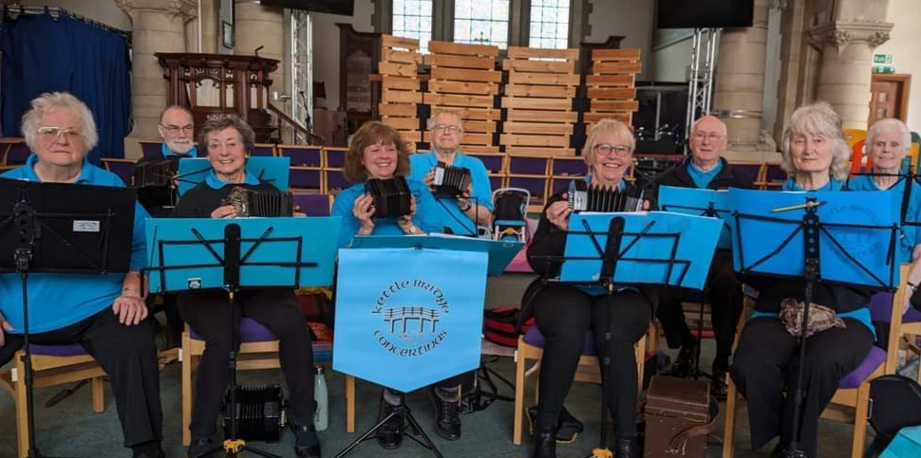1
- 10th December – Live Christmas Music by Kettle Bridge Concertinas – 11am to 1pm – Free entry
- 13th December – 4 to 5pm - A Kent Christmas: Talk & Folk Songs - £5 per person
December Exhibitions
Until 20th December – Maidstone: Through the Lens

Coming in 2026
- Children’s Lunar New Year Calligraphy
- Night at the Museum Movie Night & Activities
- Samuel Pepys Children’s Workshop
- Victoria Britain Talk by Historian
- Introduction to Maidstone Museums Collection by Collection Manager
- Mother’s Day Afternoon Tea & Stores Tour
- Observatory Tour
- Book & Clothes Swap
- Walking Tour of Maidstone
- & much much more!
Book here: https://museum.maidstone.gov.uk/whats-on/events/

Working Together to Tackle ASB
Maidstone Borough Councils Community Protection team work hard with the community to tackle antisocial behaviour.
Every report of antisocial behaviour helps us build a clearer picture and take effective action. Whether it’s nuisance bikes, catapults, or other concerns, small details can make a big difference.
Attached is a summary of the way you stay connected and keep Maidstone safe and strong.
Please share with your community.

Christmas Waste Updates for Residents

Christmas Collections
Due to the Bank Holidays around Christmas and New Year, collection rounds will change for this period. There will be changes to domestic, recycling, food and garden waste between Thursday 25 December 2025 and Monday 12 January 2026.
You can find out your revised Christmas dates at the following link
https://maidstone.gov.uk/home/other-services/seasonal-advice/tier-2-primary-areas/christmas-waste-collections
On Christmas Eve our crews will be out earlier than normal at 5am. Please leave your bins out for collection from this time.
Don’t forget to recycle all that extra waste at Christmas Find out more about what Christmas items you can recycle on our Christmas recycling webpage
Please spread the word!

On behalf of Maidstone Borough Council we wish you a very Merry Christmas and look forward to working with you in 2026.


