Crime Roundup
Map 1 – Downswood & Otham
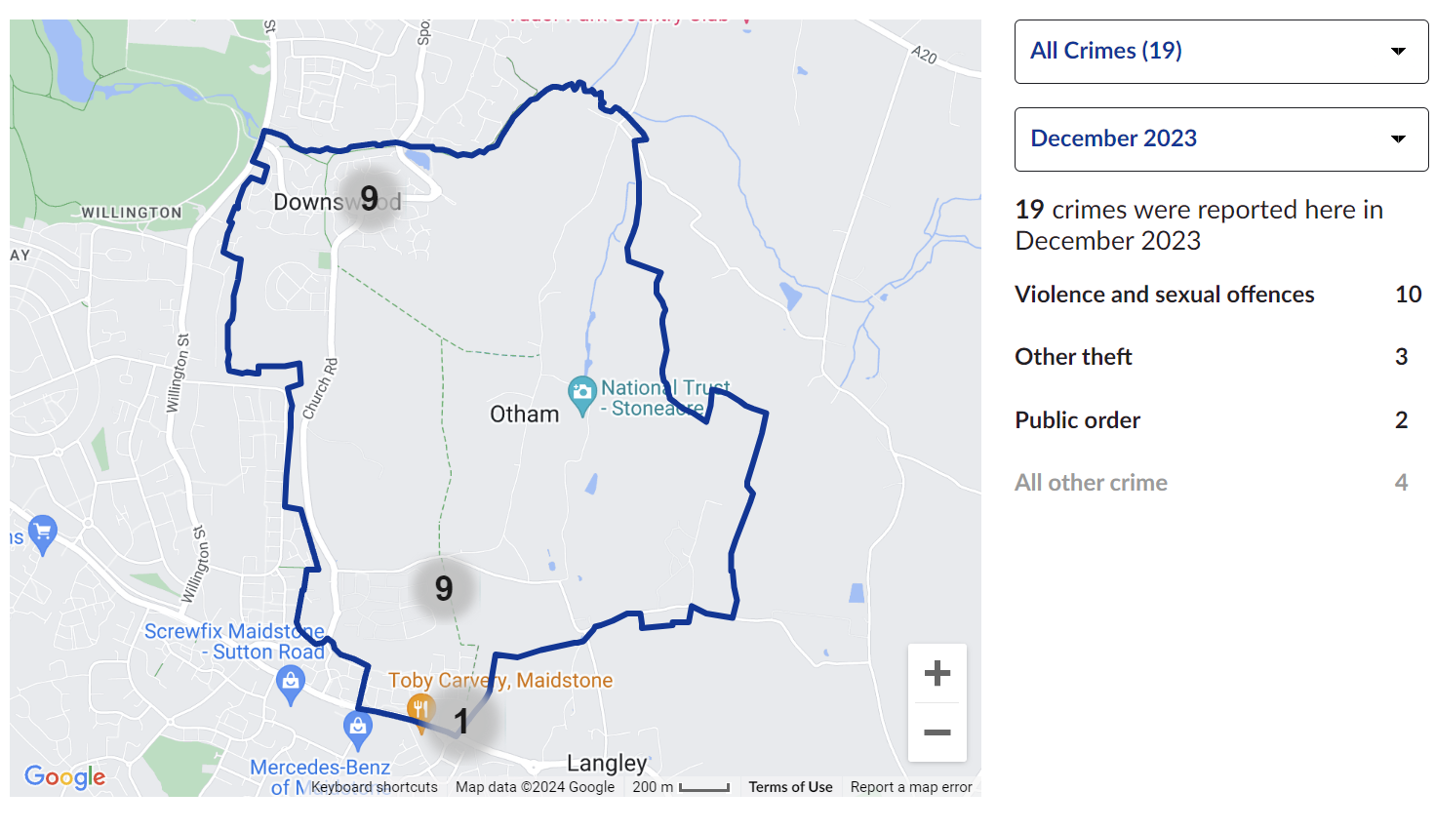

Local Area Comparison

Map 2 - Shepway
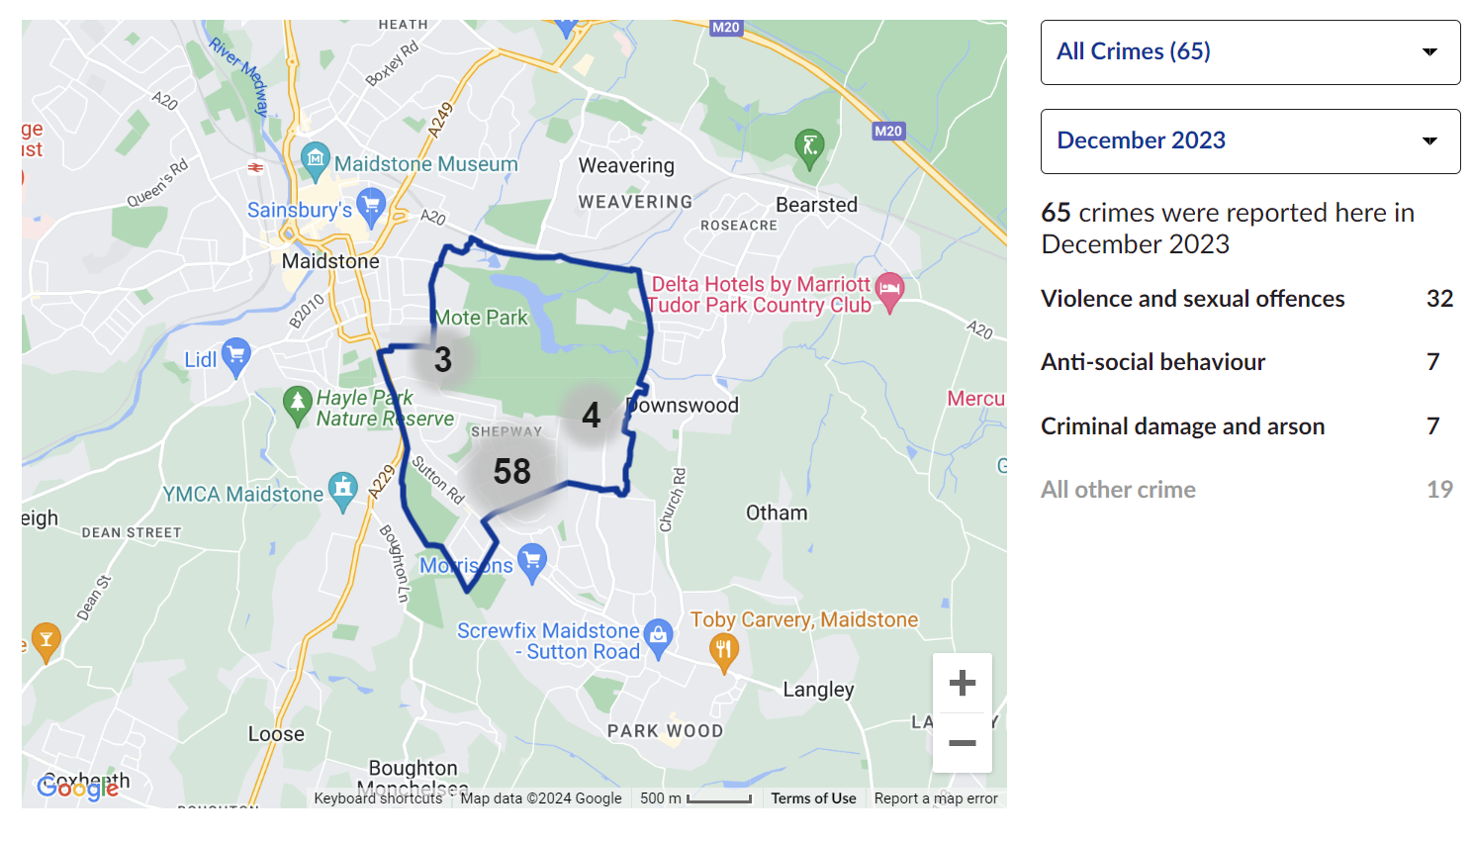

Map 3 – Bearsted
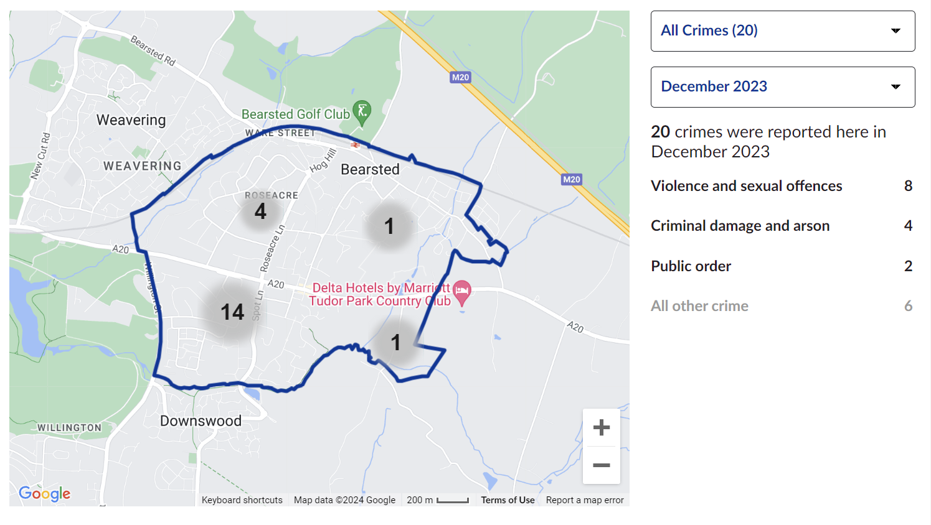
Map 4 – Parkwood
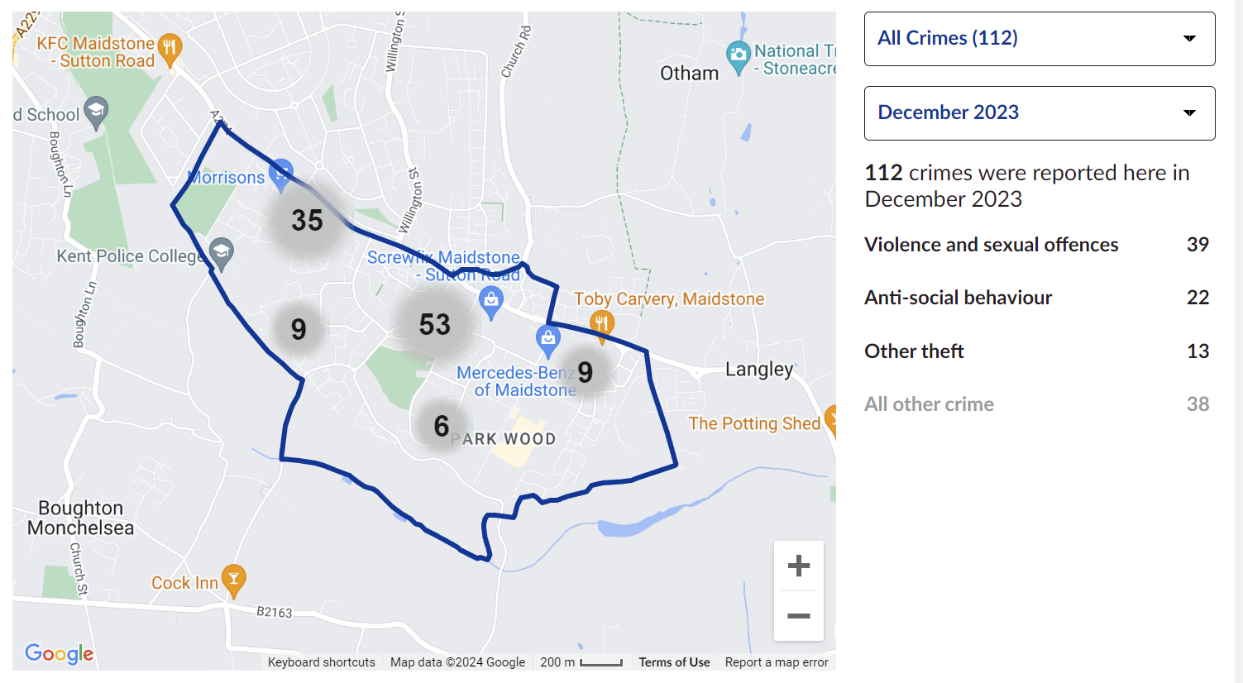

Map 5 – Leeds

